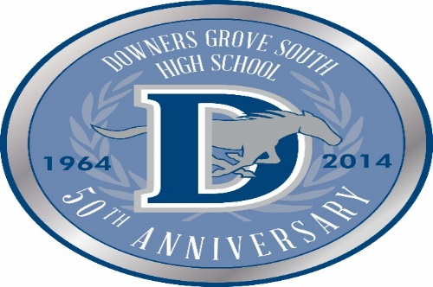
Dear Parents:
The Driver Education Department of Downers Grove South High School will be hosting a Parent Involvement Program (P.I.P. Night) for Second Semester Driver Education Students and their parents in the DGS Cafetorium on Wednesday, November 8th and Thursday, November 16th. It is mandatory parent and student must attend one of these meetings for a smooth start to your new driver’s career behind the wheel. Meetings start promptly at 7:00 p.m. & go to 8:30 p.m. If you cannot make either of these meetings, please contact the PE secretary, Mary Roe, at 630-795-8760 or via email at mroe@csd99.org. Past procedures used at DGS for drivers to obtain their permit have COMPLETELY changed. The new procedure is more parent-friendly and as long as the following steps are completed on time, you will not need to take your student to the DMV anymore; everything will be done at school. The new procedure for obtaining permits has five steps:
- Please have your student bring their Chromebook to the meeting fully charged. They will be using it for the online application process.
- Fill out the online application (this will be done by your son/daughter during Parent Involvement Program).
- Bring a $20 check or money order payable to the Secretary of State, (CASH WILL NOT BE ACCEPTED as the Secretary of State will not accept it from us when we take 175 – 250 applications over!). Please have your student’s name and ID # on the check prior to the meeting, this will alleviate the wait when you are checking in.
- Pass a written test (Administered by DGS, during the school day during PE or Health).
- Pass a vision test (Administered by DGS, during the school day during PE or Health).
First two steps will be completed by your student at P.I.P. Night while you are seeing a presentation by one of the Driver Education instructors. We ask that on P.I.P. Night you bring a $20 personal check or money order made payable to the Secretary Of State. (CASH WILL NOT BE ACCEPTED!) Please include your new driver’s name and DGS ID# on the memo line. This will complete the third step of the process. The fourth and fifth steps will be completed by your new driver during the Driver Education Pullout Day on Friday, November 17th during their PE or Health class. Students are to report to Room C146 on this day with their Chromebooks fully charged. Instructors from the Driver Education staff will administer the written permit test and vision test (if student wears glasses or contacts they must have them on this day). Both tests must be passed in order to obtain their driving permit. Finally, DGS Driver Education Staff will take all of the completed applications to the DMV and obtain the permits of all the students enrolled in Driver Education at DGS for second semester. The permits will be given back to the students in their PE or Health class.
While the students are completing their applications, parents will learn what they can expect to encounter over the next nine months and tips and tricks to help you create a safe and responsible driver. Laws related to the Graduated Drivers Licensing will also be discussed, along with time for your questions regarding Driver Education. Most importantly, the process for your new driver to obtain their permit begins on this evening.
(OVER)
Finally, the evening of the P.I.P. Night, your student will be given a study guide for the written test. It is their responsibility to go to www.cyberdriveillinois.com and find the Rules of the Road to study from. We do not receive these booklets anymore; it is a PDF File online. We also have a website at www.goo.gl/ypyozv that is full of driver education information. In all honesty, they will not pass the test without studying. Your student will be given one opportunity to pass this test at school. If they cannot pass the written or vision test at school, it will be your responsibility to obtain their permit on your own time. Unfortunately we cannot wait any longer than that to obtain the permits of the students who have passed. Please note: if your student does not obtain his/her permit by the time class begins on Monday, January 8th for second semester, your student will be dropped from the course. We know this sounds harsh, but there is no extra time to wait. We start driving on the second day of class and keep moving forward from there. We also would like your new driver to have been practicing in parking lots and basic driving routes prior to the first day of class. Without a permit, they cannot legally do this. Remember to have your student study from these two sites:
www.cyberdriveillinois.com
www.goo.gl/ypyoz
We know these new procedures may be different than what you may have done in the past; but we feel this should be easier for you in the long run. If you have ANY questions regarding this new process or anything else related to the Driver Education process, please do not hesitate to email Tim Cappelen (tcappelen@csd99.org) or email or call Mary Roe (mroe@csd99.org) at 630-795-8760.
We look forward to seeing you at the P.I.P.Night!
Scott Lange
Department Chair
PE/Health/Drivers Education

