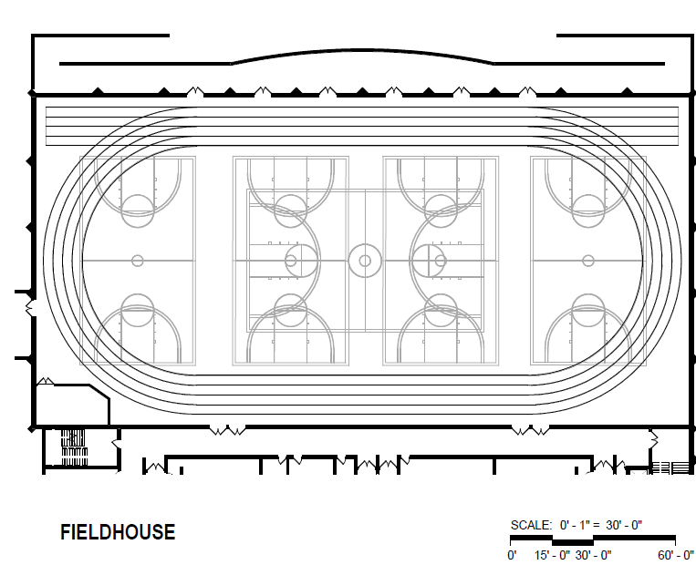
DGN FIELDHOUSE

SIZE: 27,800 square feet
Appropriate for: Basketball
Baseball
Softball
Indoor track
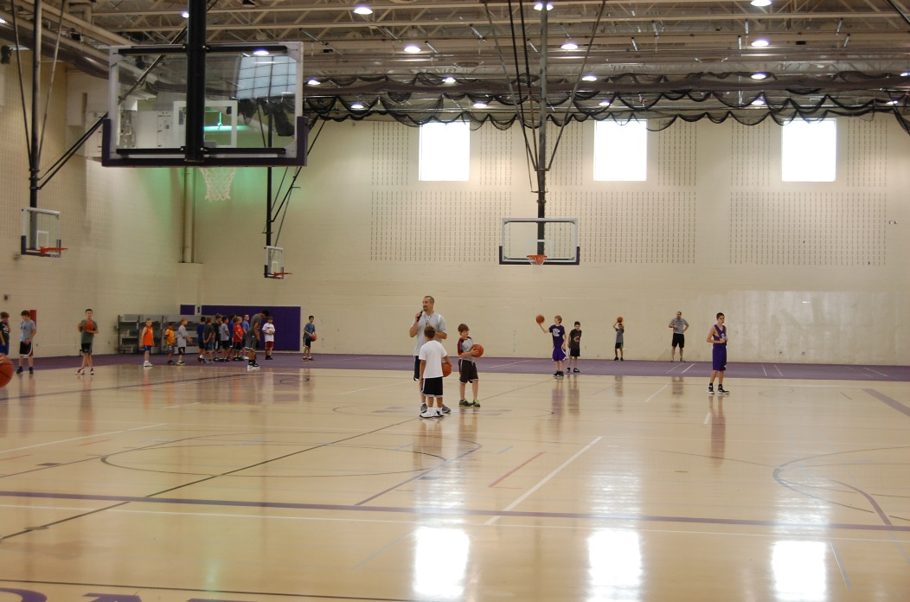
Large gatherings

Restrictions: No food or beverage other than
water is allowed in the space

Features: Basketball hoops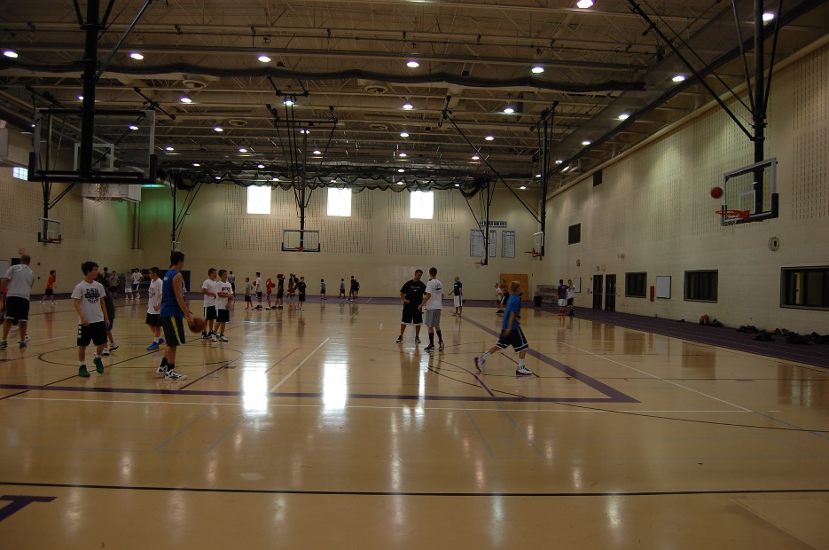
Divider screens
Batting cage

